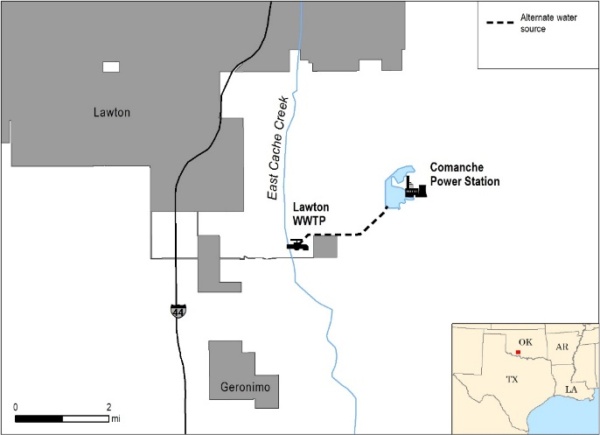
OVERVIEW
The Comanche Power Station (Comanche), owned and operated by American Electric Power (AEP), is a 235 MW NGCC plant located in Lawton, OK (population ~97,000). On average, Lawton receives ~33 inches of rainfall each year. Summers are hot and dry and average 21 days of >100°F temperatures.
This case study describes an “early adoption” example of alternate water supply given that Comanche has used reclaimed municipal effluent for approximately 45 years.
BACKGROUND
Comanche provides electricity to the City of Lawton and surrounding communities. Fort Sill U.S. Army Base was established in 1869, and the City of Lawton’s economy continues to depend on this military post.
Since Comanche began operations in 1973, the plant has used reclaimed municipal wastewater from the Lawton POTW to supply make-up water to the cooling pond reservoir.
DRIVERS
The primary driver for alternate water supply use was a lack of local freshwater supply. It was determined that groundwater in the area would not provide an adequate quantity of water and that there were no reasonable surface water sources in the area. Municipal wastewater from the Lawton POTW was then selected as the primary water source by necessity because it was the only suitable water source that AEP could locate.
IMPLEMENTATION
The contract between Comanche and the City of Lawton began in 1972. The income stream that Comanche provided to the Lawton POTW by purchasing their wastewater was utilized to upgrade the treatment processes at Lawton to meet new EPA regulations in the 1970’s.
 | Driver | Benefit | Challenge
Quantity | 
Quality
Reputation
Regulatory
Cost
The plant was initially designed and constructed to use municipal wastewater as make-up water for their cooling pond. Because Comanche uses a cooling pond rather than cooling towers, the design was similar to facilities using a freshwater sources and did not require major alterations. The combined cycle system was a fairly new technology when Comanche was constructed in the 1970’s, and this design facilitated the use of reclaimed wastewater because of the ~40% smaller cooling water volume required as compared to traditional steam-cycle plants.
The Lawton POTW water is transported about 2.5 miles to Comanche. The original concrete cylinder pipe was prone to leaks, so it was upgraded to a high density polyethylene (HDPE) pipe, paid for by AEP. Comanche chlorinates the reclaimed water on-site and also conducts fairly standard monitoring of the incoming water and water in the cooling pond (e.g., flow, pH, temperature, chlorides, sulfates, and TDS).
The water delivery contract states that Lawton POTW is obligated to supply Comanche with up to 3.5 MGD of reclaimed wastewater for 7.5 cents/1,000 gallons. This price has not changed since it was established in 1972. Comanche can exercise use of more than 3.5 MGD of water at a rate of 8.5 cents/1,000 gallons, but they have never exercised that right.
Lawton supplied Comanche with about 3.5 MGD in 2014; however, the exact amount of water can vary depending on the time of year, temperature, and extent of evaporation (e.g., greater evaporation and more makeup water needed in the summer).
The path for delivery of water from Lawton has changed over time. Originally, Lawton discharged to an onsite 500 acre-foot effluent reservoir and water was pumped from the reservoir to Comanche’s cooling pond. However, water quality issues in the effluent reservoir led to a change about 5-10 years ago. Currently, effluent from Lawton is pumped directly to Comanche’s cooling pond.
The contract with Lawton specifies the following required quality of delivered water: total phosphorus less than 1 mg/L and BOD₂₀ less than 15 mg/L. Although Lawton uses tertiary treatment, the facility has been challenged to meet their NPDES permit limits and occasionally sends lower quality water to Comanche.
BENEFITS & CHALLENGES
The main benefit of using reclaimed wastewater at Comanche is successful siting in a location that supports both the City of Lawton and the local military base. Without the use of reclaimed wastewater, it is unlikely the plant could have been sited in its current location due to a lack of another viable water source.
Another benefit of Comanche utilizing reclaimed water from Lawton POTW was that it provided Lawton with the money to upgrade the treatment processes at the plant to meet new discharge regulations in the 1970’s.
It is estimated that Lawton POTW water is less expensive compared to surface water in the region, providing a cost advantage to using reclaimed wastewater. Drawing from surface water would require a permit and Comanche would have to continually demonstrate use or else they could lose it.
AEP briefly mentions Comanche’s use of reclaimed water in their CDP Water disclosure; however, it has not been emphasized, possibly because it is not a new water-related practice. Therefore, the reputational benefit is currently small but there may be potential to highlight this facility in future water risk and sustainability reporting.
The main challenges associated with using reclaimed wastewater at Comanche relate to variable water quality. When Lawton initially discharged to a 500 acre-foot reservoir prior to transport to Comanche, the water would occasionally have issues with TSS, TDS, algae, and eutrophication. Even though the City reservoir is no longer used, the water supplied to Comanche has still had occasional water quality issues. There have also been instances of high algae levels and eutrophication in Comanche’s cooling pond.
LESSONS LEARNED
A cooling pond system provides greater flexibility for reclaimed water use with variable quality.
Because Comanche utilizes a cooling pond, it can use water that is not as high of quality as would be required for cooling towers. Towers more quickly concentrate contaminants in the recirculating water and high levels of pollutants can lead to problematic scaling and biofouling.
Utilizing an alternate water source provided flexibility for power plant siting.
Utilities in water stressed regions are used to not having abundant water resources and thus site plants primarily based on transmission and fuel availability. The option to use a reclaimed wastewater source provided flexibility in siting the Comanche power plant at a beneficial location.
REFERENCES
AEP. 2014. American Electric Power 2014 Corporate Accountability Report- GRI Report. URL: http://2014.aepsustainability.com/fastfacts/docs/2014-GRI.pdf [Accessed 10/25/2016].
Personal communication, AEP staff, 2016. Greg Carter and Tim Lohner.

VERIFICATION
Information presented in this case study was provided through interviews with AEP staff in October 2016, who have reviewed this case study for accuracy.

